# USER-MANUAL

#### **1. Installing XAMPP**

1. **Download XAMPP:**
   * Visit the XAMPP website and download the version suitable for your operating system.
2. **Install XAMPP:**
   * Run the installer and follow the on-screen instructions.
   * Choose the default components (Apache, MySQL, PHP) and installation directory (usually C:\xampp).

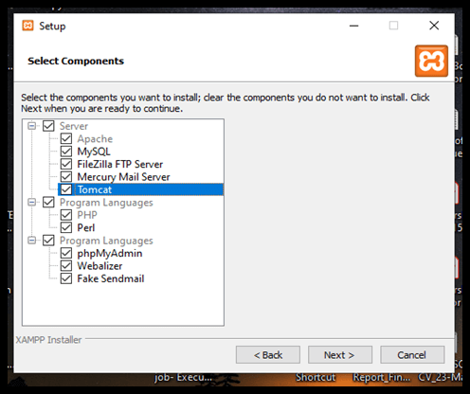

1. **Start XAMPP:**
   * Open the XAMPP Control Panel from your installation directory or Start menu.
   * Click the "Start" buttons next to "Apache" and "MySQL" to start the web server and database.

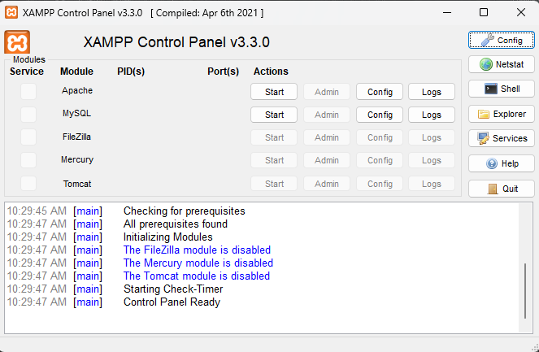

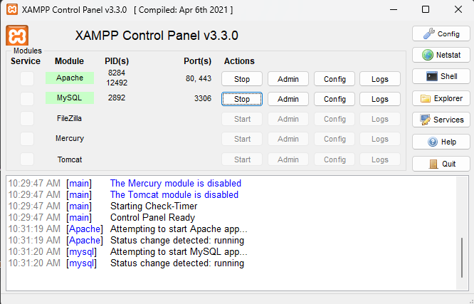

#### **2. Setting Up the Student Management System**

1. **Extract the student.zip File:**
   * Locate the student.zip file you received.
   * Right-click on the file and select "Extract All" to extract the contents.
   * Choose a destination folder for the extracted files.
2. **Move the Extracted Folder:**
   * After extraction, you will have a folder named student.
   * Cut the student folder and navigate to the XAMPP installation directory (usually C:\xampp\).
   * Open the htdocs folder inside the XAMPP directory and paste the student folder here.

#### **3. Configuring the Database Connection**

1. **Access phpMyAdmin:**
   * Open your web browser and type http://localhost/phpmyadmin in the address bar to access phpMyAdmin.

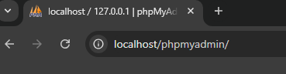

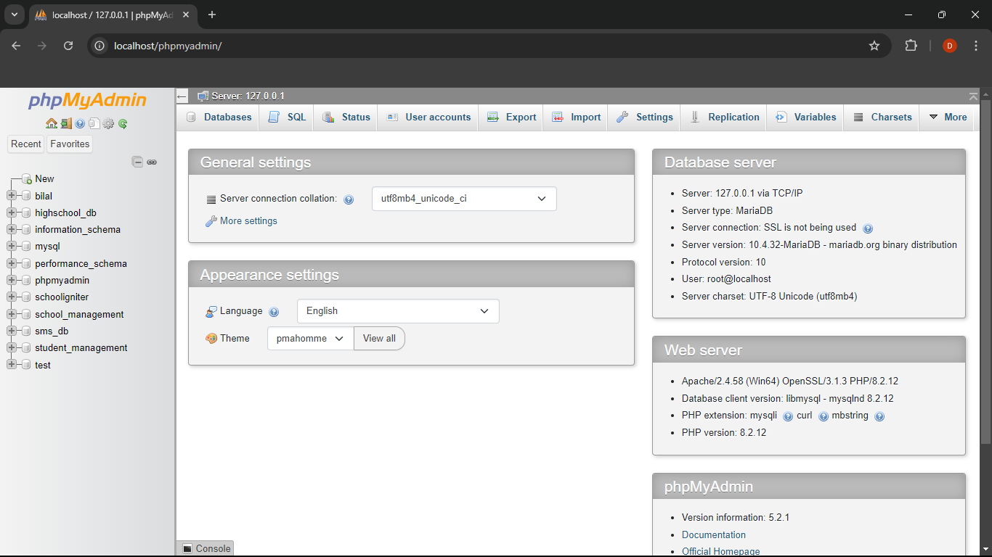

1. **Copy Server Name or Address:**
   * In phpMyAdmin, look for the server information, which is usually displayed on the right side of the homepage.
   * Copy the server name or address (e.g., localhost).



1. **Edit db_connect.php:**
   * Navigate to the student folder inside htdocs and find the assets/php/db_connect.php file.
   * Open db_connect.php in a text editor.
   * Paste the copied server name or address into the $servername variable.

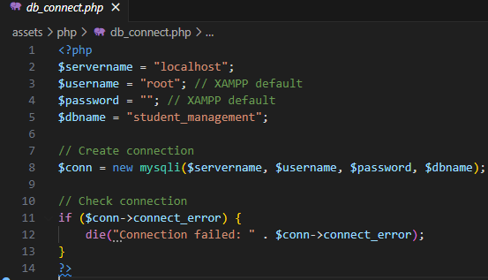

#### **4. Setting Up the Database**

1. **Create a New Database:**
   * In phpMyAdmin, click on the "Databases" tab at the top.
   * Enter student_management as the database name and click "Create."
2. **Import the Database File:**
   * With the student_management database selected, click on the "Import" tab.
   * Click "Choose File" and select the database.sql file from the database folder inside the student folder.
   * Click "Go" to import the SQL file and create the necessary tables.**5. Running the Website**
3. **Access the Website:**
   * Open your web browser and type http://localhost/student in the address bar.
   * The Student Management System should now be accessible

